Day6:
Install django :
Command
Pip install django
For create project
E:
Django-admin start project djangointernship
Cd djangointernship
For run server
Python manage.py runserver
For create application
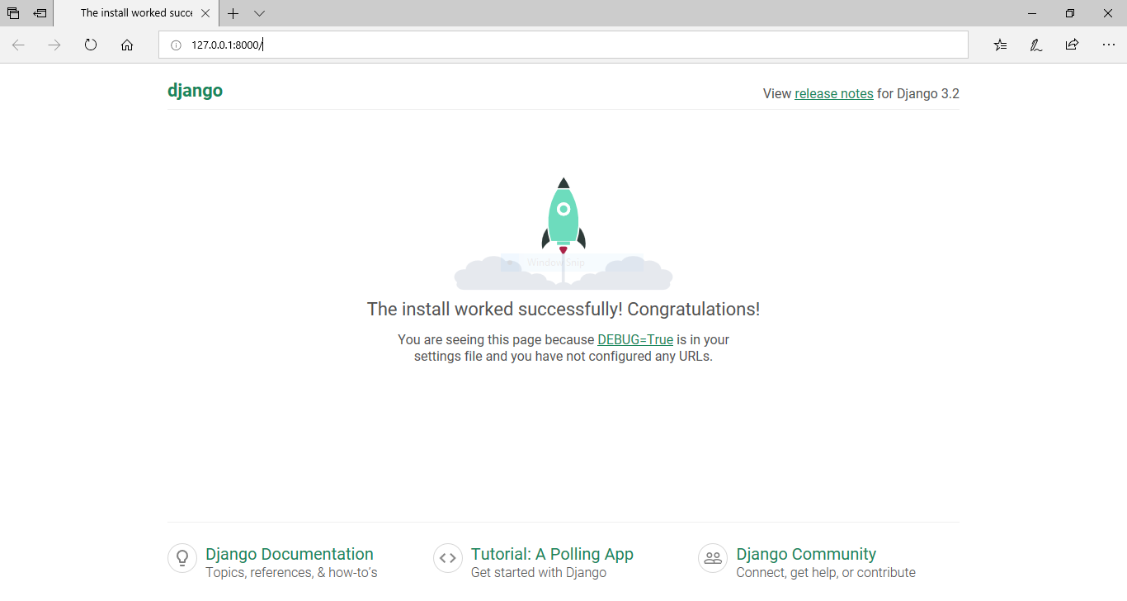
Python manage.py startapp myapp
Python manage.py migrate

